BIL-533

HW 1

***Towers of Hanoi***

In this homework, we are considering the Tower of Hanoi with *n* discs. You are supposed to write a pseudo code for the Tower of Hanoi program using

1. Iterative approach
2. Recursive approach

*Background:* Tower of Hanoi is a mathematical puzzle which consists of three towers (pegs) and more than one disks of different sizes

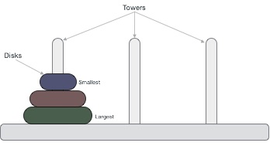

Disks are stacked upon in an ascending order, i.e. the smaller one sits over the larger one.

The mission is to move all the disks to some another tower without violating the sequence of arrangement. A few rules to be followed for Tower of Hanoi are −

* Only one disk can be moved among the towers at any given time.
* Only the "top" disk can be removed.
* No large disk can sit over a small disk.

*Note:* Tower of Hanoi puzzle with n disks can be solved in minimum **2n−1** steps.